Literacy support worksheet answers

3.1 Scientists refine models and theories over time

Pages 66–69

The history of the periodic table

1 Who created the modern periodic table?

|  |
| --- |
|  |

2 Why did Mendeleev leave gaps in the periodic table?

|  |
| --- |
|  |

3 How many elements did the ancient Greeks believe in?

|  |
| --- |
|  |

4 Name the two steps Mendeleev took to organise the elements on the periodic table using cards.

|  |
| --- |
|  |
|  |
|  |

5 Match each famous scientist with their contribution to the development of the periodic table.

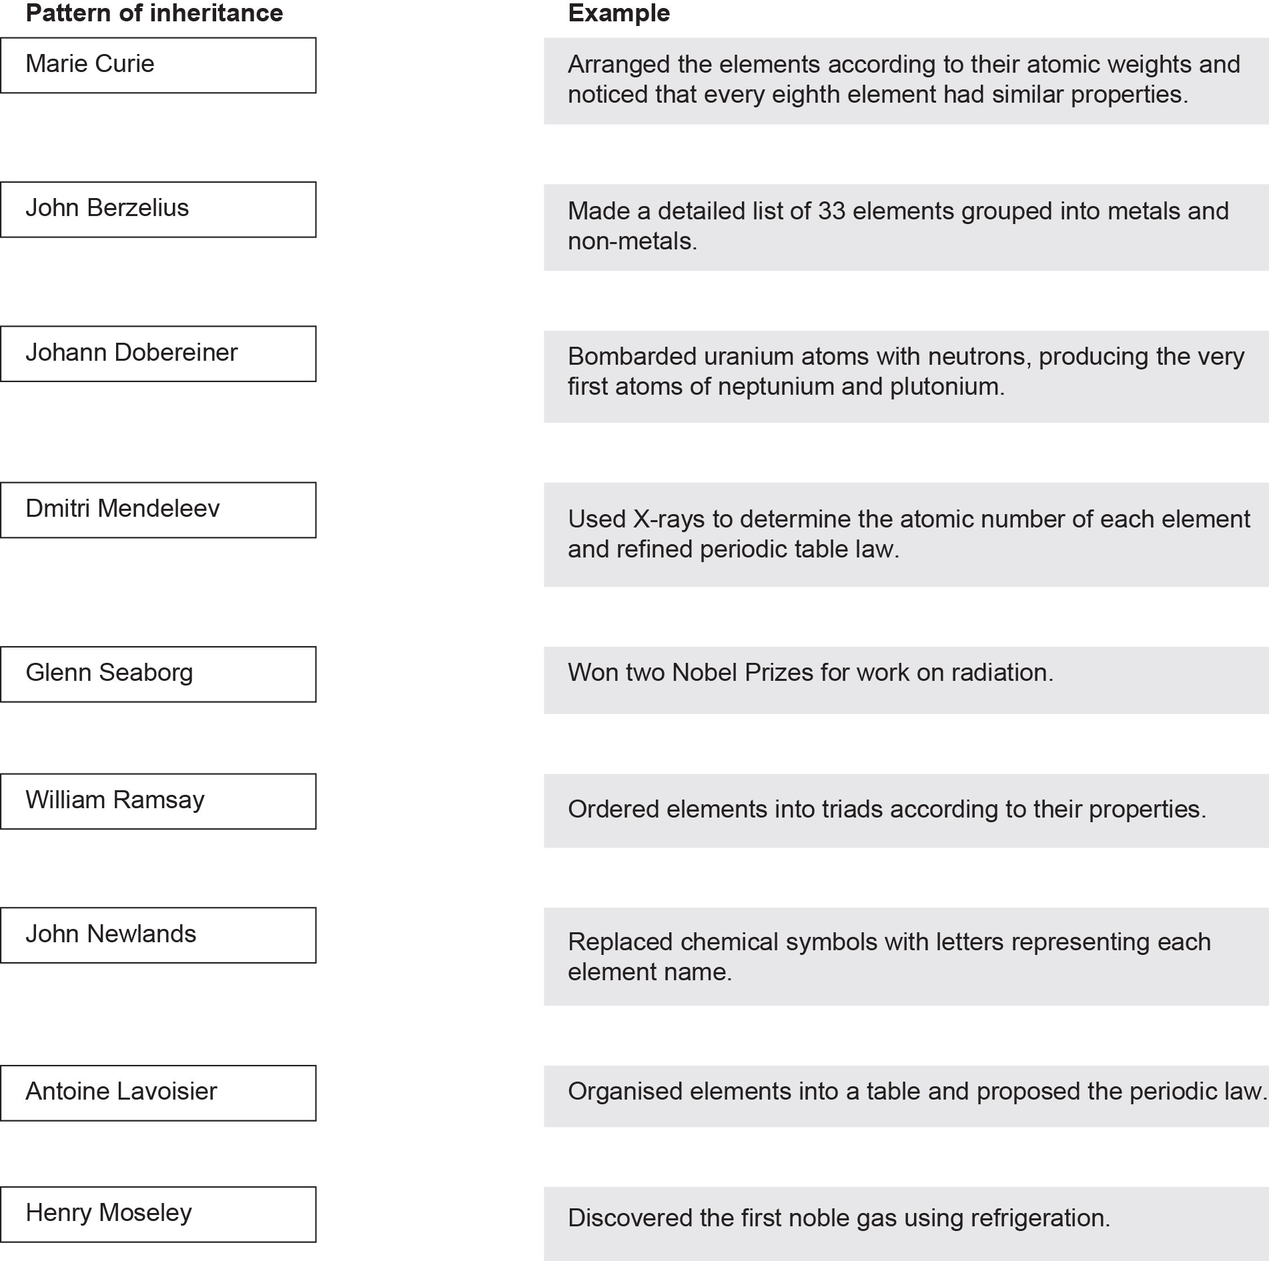

Word detective – Fill in the blanks

6 Fill in the blanks in the timeline below to show how the periodic table has changed.

|  |  |  |
| --- | --- | --- |
| Scientist | Year | Discovery |
| Ancient Greeks | 2000 years ago | Thought everything was made of four \_\_\_\_\_\_\_\_\_\_\_\_\_\_\_\_\_\_\_ mixed together in different ratios. |
| Robert Boyle | 1661 | Suggested that an element was a \_\_\_\_\_\_\_\_\_\_\_\_\_\_\_\_\_\_\_\_ that cannot be broken down into a simpler substance in a chemical reaction. |
| Antoine Lavoisier | 1789 | Made a detailed list of 33 elements grouped into metals and \_\_\_\_\_\_\_\_\_\_\_\_\_\_\_\_\_\_\_\_. |
| Jakob Berzelius | 1820s | Replaced the geometric patterns used as chemical symbols with letters that were an \_\_\_\_\_\_\_\_\_\_\_\_\_\_\_\_\_\_\_\_ of the element’s name. Also, used the weight of hydrogen to develop an organised system of \_\_\_\_\_\_\_\_\_\_\_\_\_\_\_\_\_\_\_\_ weights, with all remaining elements believed to have a whole number above 1. |
| Johann Dobereiner | 1829 | Grouped 40 elements into \_\_\_\_\_\_\_\_\_\_\_\_\_\_\_\_\_\_\_\_ according to their properties. These groupings were important in identifying patterns of behaviour, which helped with more accurate predictions about atomic\_\_\_\_\_\_\_\_\_\_\_\_\_\_\_\_\_\_\_\_. |
| John Newlands | 1864 | Arranged the elements according to their atomic\_\_\_\_\_\_\_\_\_\_\_\_\_\_\_\_\_\_\_\_, and noticed that every eighth element had similar properties. This pattern was considered a recurring or \_\_\_\_\_\_\_\_\_\_\_\_\_\_\_\_\_\_\_\_ feature among the elements. |
| Dmitri Mendeleev | 1869 | Wrote the names and \_\_\_\_\_\_\_\_\_\_\_\_\_\_\_\_\_\_\_\_ of each element on small cards and arranged them in order of atomic weight. The cards were then rearranged, maintaining their order, into groups with \_\_\_\_\_\_\_\_\_\_\_\_\_\_\_\_\_\_\_\_ properties, creating the modern periodic table. |
| William Ramsay | 1894 | Used the technology of \_\_\_\_\_\_\_\_\_\_\_\_\_\_\_\_\_\_\_\_ to remove water, carbon dioxide, oxygen and nitrogen from air, but found some unknown gas left behind. This was argon, the first of the \_\_\_\_\_\_\_\_\_\_\_\_\_\_\_\_\_\_\_\_ gases to be discovered. |
| Marie Curie | 1911 | Identified and purified elements of the periodic table. Also, won two Nobel Prizes for her work on\_\_\_\_\_\_\_\_\_\_\_\_\_\_\_\_\_\_\_\_. |
| Henry Moseley | 1913 | Used \_\_\_\_\_\_\_\_\_\_\_\_\_\_\_\_\_\_\_\_ to determine the atomic number of each element and refined periodic table law. |
| Glenn Seaborg | 1940 | Bombarded uranium atoms with neutrons. This produced the very first atoms of neptunium and\_\_\_\_\_\_\_\_\_\_\_\_\_\_\_\_\_\_\_\_. |

Literacy support worksheet answers

3.2 The structure of an atom determines its properties

Pages 70–73

Atomic structure

1 What is the atomic number and name of an atom determined by?

|  |
| --- |
|  |

2 Fill in the equation below:

Relative atomic mass = \_\_\_\_\_\_\_\_\_\_\_\_\_\_\_\_\_\_\_\_\_ + \_\_\_\_\_\_\_\_\_\_\_\_\_\_\_\_\_\_\_\_\_

3 On the periodic table, what is a horizontal row called?

|  |
| --- |
|  |

4 On the periodic table, what is a vertical column called?

|  |
| --- |
|  |

5 What is the equation to calculate how many electrons in a shell?

Electrons in a shell = \_\_\_\_\_\_\_\_\_\_\_\_\_\_\_\_\_\_

6 Label, on the shell diagram below, where the electrons would be found for an oxygen atom.

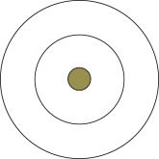

7 Calculate the number of protons, neutrons and electrons for each atom using the periodic table and a calculator. Fluorine has been done for you.

|  |  |  |  |
| --- | --- | --- | --- |
| Atom | Number of protons =  atomic number  (found at the top of the letter) | Number of neutrons =  mass number  (found at the bottom of the letter)  – atomic number | Number of electrons  =  atomic number |
| Nitrogen (N) |  |  |  |
| Oxygen (O) |  |  |  |
| Fluorine (F) | 9 | 19.00 – 9 = 10 | 9 |
| Neon (Ne) |  |  |  |

8 Draw the electron configuration for the following elements, using the rules in the Bohr table below.

Bohr model of the atom

|  |  |
| --- | --- |
| Shell number form the nucleus outwards (n) | Maximum number of electrons in the shell (2n²) |
| 1 | 2 |
| 2 | 8 |
| 3 | 18 |
| 4 | 32 |

|  |  |  |  |
| --- | --- | --- | --- |
| Nitrogen | Oxygen | Fluorine | Neon |
| Phosphorus | Silicon | Chlorine | Argon |

Word detective – Match the words

9 Match the following elements with their descriptions.

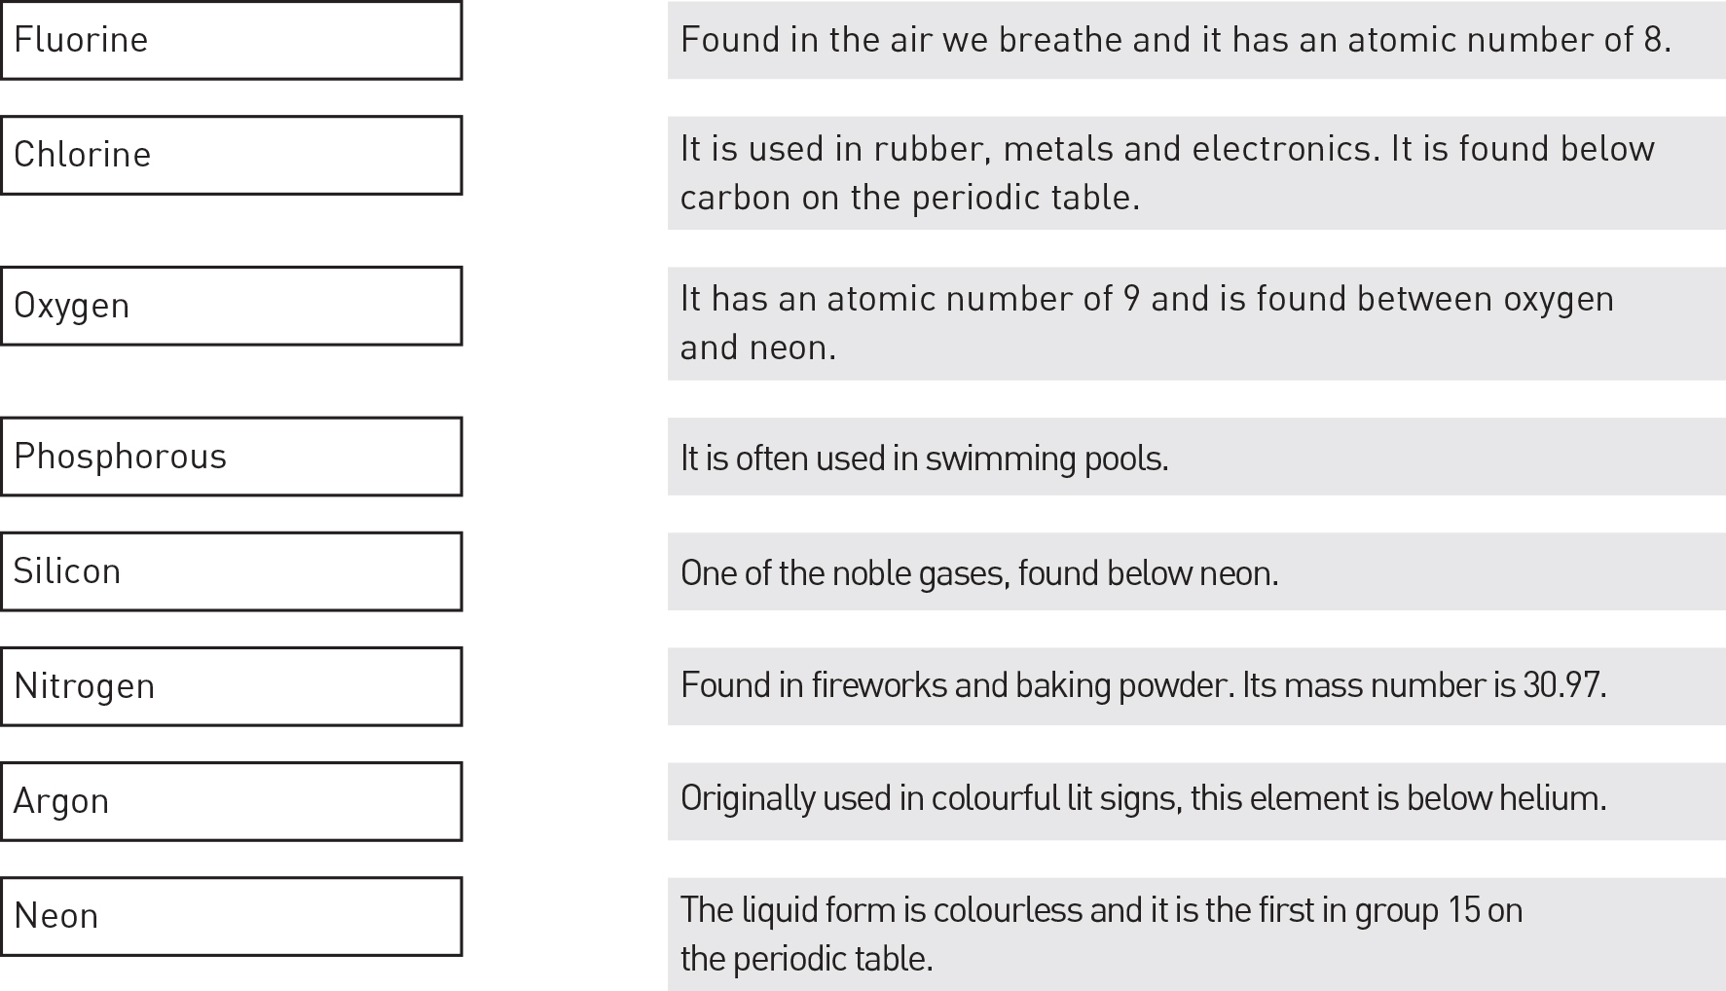

Literacy support worksheet answers

3.3 Groups in the periodic table have properties in common

Pages 74–75

Trends of metals in the periodic table

1 Name five properties that all metals have in common.

|  |
| --- |
|  |
|  |
|  |

2 For the three metal groups in the periodic table, fill in the blanks in the table below.

|  |  |  |  |
| --- | --- | --- | --- |
| Name | Alkali metals | Alkaline earth metals | Transition metals |
| Group number | 1 | 2 | 3–12 |
| Properties | • Soft  • React with air to become \_\_\_\_\_\_\_\_\_\_  • React violently with water to produce hydrogen gas and a \_\_\_\_\_\_\_\_\_\_\_ solution  • More \_\_\_\_\_\_\_\_\_\_\_ down the group | • Low \_\_\_\_\_\_\_\_ points  • Relatively soft and very \_\_\_\_\_\_\_\_\_\_\_\_, although in general they are not quite as reactive as group 1  • React with water, some strongly, producing \_\_\_\_\_\_\_\_\_\_\_ gas and a basic solution  • More reactive down the \_\_\_\_\_\_\_\_\_ | • Some are \_\_\_\_\_\_\_\_  • Gold and \_\_\_\_\_\_\_\_\_ are the only metals that are not silvery in colour  • Many form coloured \_\_\_\_\_\_\_\_\_\_\_\_\_\_  • Many form more than one compound with a \_\_\_\_\_\_\_\_\_\_\_\_ such as chlorine (e.g. iron forms FeCl2 and FeCl3) |

Word detective – Draw a Venn diagram

3 Draw a Venn diagram and fill it in to show the similarities and differences between alkali metals and alkaline earth metals.

|  |
| --- |
|  |

Literacy support worksheet answers

3.4 Non-metals have properties in common

Pages 76–77

Trends of non-metals in the periodic table

1 Name six properties of non-metals.

|  |
| --- |
|  |
|  |
|  |

2 Where can you find non-metals on the periodic table?

|  |
| --- |
|  |
|  |

3 What do metalloids have in common with metals?

|  |
| --- |
|  |
|  |

4 Name two metalloids that are ‘semiconductors’.

|  |
| --- |
|  |
|  |

5 Where would you find non-metals on Earth?

|  |
| --- |
|  |
|  |

Word detective – Fill in the table

6 Fill in the table comparing halogens and noble gases. Write the properties as dot points.

|  |  |  |
| --- | --- | --- |
| Name | Halogens | Noble gases |
| Group number |  |  |
| Properties |  |  |

Literacy support worksheet answers

3.5 Metal cations and non-metal anions combine to form ionic compounds

Pages 78–79

Ionic compounds

1 What is the difference between an atom and an ion?

|  |
| --- |
|  |
|  |
|  |

2 When are electron valance shells most stable?

|  |
| --- |
|  |
|  |
|  |

3 What is likely to happen in the following examples?

a A valance shell has only 1–3 electrons.

|  |
| --- |
|  |
|  |

b A valance shell has 7 electrons.

|  |
| --- |
|  |
|  |

4 What is an ion?

|  |
| --- |
|  |

5 What would happen to the charge of an atom if:

a it lost electrons?

|  |
| --- |
|  |

b it gained electrons?

|  |
| --- |
|  |

6 Fill in the blanks for the definitions in the table below.

|  |  |
| --- | --- |
| Word | Definition |
| Cation | Positively charged \_\_\_\_\_\_\_\_\_\_\_ |
| Anion | Negatively charged \_\_\_\_\_\_\_\_\_\_\_\_ |
| Ionic bond | Bonds that form when \_\_\_\_\_\_\_\_\_\_\_\_ interact |
| Ionic compounds | Compounds held together by ionic \_\_\_\_\_\_\_\_\_\_\_\_ |
| Polyatomic ions | Ions that are made up of more than one \_\_\_\_\_\_\_\_\_\_\_\_ |

7 Complete the following table to demonstrate the number of electrons gained or lost by atoms to form ions. The first and last one have been completed for you.

|  |  |  |
| --- | --- | --- |
| Group number | Number of valence electrons | Number of electrons gained or lost |
| 1 | 1 | Lose 1 |
| 2 |  |  |
| 13 |  |  |
| 15 | 5 | Gain 3 |
| 16 |  |  |
| 17 |  |  |
| 18 | 8 | Stable |

Word detective – Draw and label

8 Draw the electron configuration of lithium and fluorine, and then redraw these configurations to demonstrate how an electron is donated between the atoms. (Hint: Use the information in Figure 3.26 in the student book to help you.)

|  |
| --- |
|  |

Literacy support worksheet answers

3.6 Non-metals combine to form covalent compounds

Pages 80-81

Covalent bonding

1 What is a covalent bond?

|  |
| --- |
|  |
|  |

2 Which types of atoms can covalent bonding occur between?

|  |
| --- |
|  |

3 What do the two atoms share when they convalently bond?

|  |
| --- |
|  |

4 Sequence the process of a hydrogen molecule forming by ordering the following from 1 to 5.

\_\_\_\_\_\_\_\_ Each atom now has a stable electron configuration because its outer shell is full.

\_\_\_\_\_\_\_\_ Two uncharged hydrogen atoms come close together.

\_\_\_\_\_\_\_\_ The electrons travel into the spaces surrounding the nuclei of each atom.

\_\_\_\_\_\_\_\_ The atoms potentially merge, with the nuclei of both now sharing the two electrons.

\_\_\_\_\_\_\_\_ The electrons are drawn into the region between two nuclei.

5 Where would you find electrons in covalent bonding?

|  |
| --- |
|  |

6 Molecules are usually drawn with a line as a chemical bond. How many electrons are in this bond?

|  |
| --- |
|  |

7 Complete the following sentence:

‘Almost all molecular substances do not \_\_\_\_\_\_\_\_\_\_\_\_\_\_\_\_\_\_\_\_\_\_\_\_\_\_\_\_\_\_\_\_\_.’

|  |
| --- |
|  |

Word detective – Draw and label

8 Draw and label the covalent bonding in the following molecules. (Hint: Use the periodic table in Figure 3.9 in the student book to help you.) The first one has been done for you.

|  |  |
| --- | --- |
| Carbon dioxide (CO2)  L:\1. Publishing and Editorial\1. Product\Oxford Science\Oxford Science 10\3. Extras\6. Student worksheets\Artwork\4. Final jpgs\SW0330_01095.jpg | Methane (CH4) |
| Hydrofluoric acid (HF) | Carbon tetrachloride (CCl4) |

Literacy support worksheet answers

3.7 Metals form unique bonds

Pages 82–83

Metallic bonding

1 What characteristic makes metal a good conductor?

|  |
| --- |
|  |
|  |

2 What are metal alloys?

|  |
| --- |
|  |
|  |

3 Why are some alloys called ‘smart’?

|  |
| --- |
|  |
|  |

4 The way atoms are arranged in metals allows them to slide over each other when bent or hammered into place. Draw a diagram to demonstrate this idea.

|  |
| --- |
|  |

5 Name three structural features that metals have in common.

|  |
| --- |
|  |
|  |
|  |

6 How does temperature affect conductivity in metals?

|  |
| --- |
|  |
|  |

7 Why are metals shiny?

|  |
| --- |
|  |

Word detective – Sequencing

8 Write a number next to each element in the table below, from most conductivity to least conductivity. Then explain where these metals can be used every day. Some have been completed for you.

|  |  |  |  |
| --- | --- | --- | --- |
| Order of conductivity | Element | Electrical conductivity  (× 106 ohm-1 cm-1) | Everyday usage |
| 9 | Lead | 0.048 | In acid batteries |
|  | Silver | 0.63 |  |
| 7 | Carbon (graphite) | 0.100 | Electrical cells such as batteries |
|  | Copper | 0.596 |  |
|  | Gold | 0.452 |  |
| 8 | Iron | 0.093 | In vehicles like cars |
|  | Aluminium | 0.37 |  |
| 5 | Magnesium | 0.226 | In light alloys in aircraft |
| 6 | Sodium | 0.210 | Glass, textiles and baking soda |

Literacy support worksheet answers

3.8 Nanotechnology involves the specific arrangement of atoms

Pages 84–85

Nanotechnology

1 What unit do we use to measure in nanotechnology?

|  |
| --- |
|  |

2 What is the diameter of the average atom?

|  |
| --- |
|  |

3 How big is a nanobot?

|  |
| --- |
|  |
|  |

4 What is nanotechnology?

|  |
| --- |
|  |
|  |
|  |

5 Name three things nanobots can be used for.

|  |
| --- |
|  |
|  |
|  |

6 How could nanobots help us to stay healthy?

|  |
| --- |
|  |
|  |

s7 What properties do metals and carbon nanotubes have in common? (Hint: Use the information on page 84 in the student book to help you.)

|  |
| --- |
|  |
|  |
|  |

8 What are the differences in properties between metals and carbon nanotubes?

|  |
| --- |
|  |
|  |
|  |

Word detective – Complete the table

9 Complete the following table about carbon nanotubes. List adjectives that could be used to describe carbon nanotubes in the left-hand column. List potential uses for carbon nanotubes in the right-hand column. An example has been completed for you.

|  |  |
| --- | --- |
| Adjectives | Uses |
| Hard | In medicine, to fix damaged brains |
|  |  |
|  |  |
|  |  |
|  |  |